Where there is no light there is darkness, we call this a shadow. In fact at night we are in the shadow of the Earth.
You can see from the two diagrams that there are two types of shadow; a crisp edged one formed by a point source of light and a fuzzier one that is formed by a larger source.
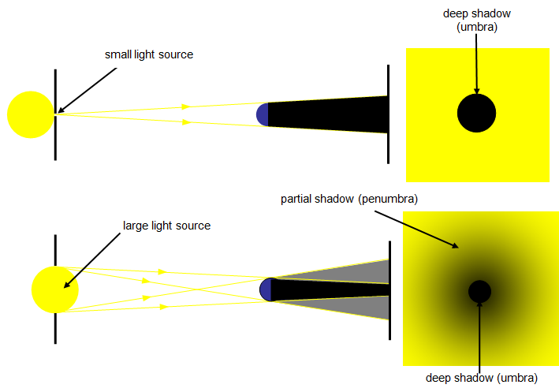

The region of deep, total shadow is called the UMBRA and the region of partial shadow is called the PENUMBRA. The umbra is a region where no light can get to while the penumbra is a region where some light can reach.

Investigation Planning Sheet

1. PLANNING
1.1 Aim
What are you trying to find out? What problem are you trying to solve?
______________________________________________________________________________________________________________________________________________________________________________________________________________________________

1.2 Variables
You can only change one variable at a time and measure its effect. Select the variable that you would like to investigate. The rest of the variables must be kept the same.

Change (Independent) ______________________________________________
Measure (Dependent) ______________________________________________
Keep the Same (Controlled) ______________________________________________
______________________________________________
______________________________________________
______________________________________________

1.3 Hypothesis
A statement about what you think will happen. This statement needs to link the independent and dependent variables.
________________________________________________________________________________________________________________________________________________________________________________________________________________________________________________________________________________________________________

2. CONDUCTING AND RECORDING
2.1 Equipment
Write a list of all the equipment you will need to conduct your experiment.

- ______________________
- ______________________
- ______________________
- ______________________
- ______________________
- ______________________
- ______________________
- ______________________
- ______________________
- ______________________

2.2 Procedure
Design a method by which you can slowly change one variable and measure its affect on the other.
- ____________________________________________________________________________________________________________________________________________
- ____________________________________________________________________________________________________________________________________________
- ____________________________________________________________________________________________________________________________________________
- ____________________________________________________________________________________________________________________________________________
- ____________________________________________________________________________________________________________________________________________
- ____________________________________________________________________________________________________________________________________________
- ____________________________________________________________________________________________________________________________________________
- ____________________________________________________________________________________________________________________________________________
- ____________________________________________________________________________________________________________________________________________
- ____________________________________________________________________________________________________________________________________________
- ____________________________________________________________________________________________________________________________________________
- ____________________________________________________________________________________________________________________________________________
- ____________________________________________________________________________________________________________________________________________
- ____________________________________________________________________________________________________________________________________________
2.3 Results
Construct a table so that you can record the changes in the variables.

3. ANALYSING
3.1 Graphing
Draw a graph of your results. Use the following rules to determine which type of graph to construct. Remember to use a line of best fit if you are constructing a line graph.

Independent Data | Dependent Data | Type of Graph
Data is continuous (eg. time) | Data is continuous (eg. height) | Line graph
Data is in categories (eg. eye colour) | Data is numerical (eg. number of people) | Column graph

3.2 Analysing Your Results
Do your results support your hypothesis or not?
____________________________________________________________________________________________________________________________________________________

Explain how you used your results to come to your conclusion above.
________________________________________________________________________________________________________________________________________________________________________________________________________________________________________________________________________________________________________
4. EVALUATION
4.1 Errors
What are the possible sources of error in your investigation?
______________________________________________________________________________________________________________________________________________________________________________________________________________________________

How might these sources of error affect your data?
______________________________________________________________________________________________________________________________________________________________________________________________________________________________

4.2 Improving Your Investigation
What changes would you make to your investigation to improve your results?
__________________________________________________________________________________________________________________________________________________________________________________________________________________________________________________________________________________________________________________________________________________________________________________

5. REPORT
You need to write a report of your experiment. Your report should include the following:
Aim: What is the aim or purpose of your investigation?
Hypothesis: Your prediction in the form of a statement. This needs to link your independent and dependent variables.
Equipment: A list of all the equipment you used in your investigation.
Diagram of Equipment: A labelled diagram of how you set up your equipment to conduct your investigation.
Method: A list of the steps you went through to conduct your investigation.
Results: The results of your investigation presented in both a table and a graph.
Discussion: Comment on whether or not your results supported your hypothesis, what were the possible sources of error in the investigation and what you could do to improve your investigation.
Conclusion: Short statement to sum up your experiment.

